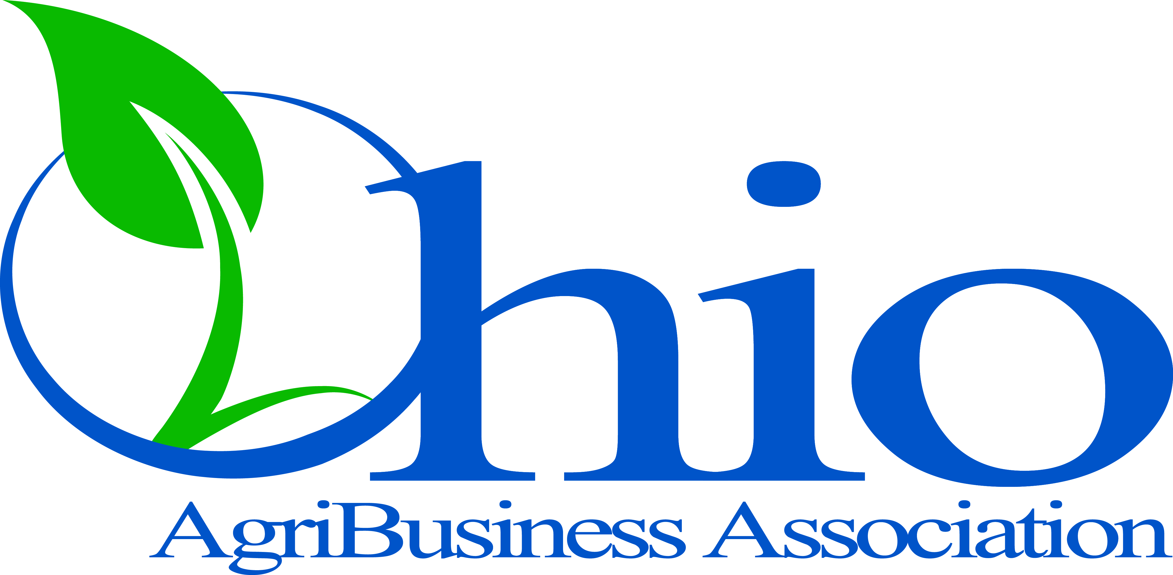
Strategic Plan
Executive Summary

The Ohio Agribusiness Association (OABA) is a trade association originally established in the late 1800s to represent the best interests of businesses that serve Ohio agriculture. Businesses who make up OABA membership are in manufacturing, wholesale, and retail and represent business sectors ranging from agronomic inputs (seed, plant food, crop protection), livestock feed and nutrition, grain marketing, insurance, equipment to financial services. With more than 250 members and with a board that includes members or employees of OABA members, OABA is the leading advocate for Ohio agribusiness.
OABA’s Mission Statement
The leading advocate for Ohio agribusiness by creating a sustainable business climate through collaborative policy leadership, continuous education and effective communication.

OABA Goals
- Become the authority on legislative and regulatory issues affecting our members.
- Deliver effective and dynamic education to attract, retain and develop talent.
- Produce and broadcast timely and quality communication.
- Increase revenue through broadening and diversifying our membership.

Key Performance Areas
Become the authority on legislative and regulatory issues affecting our members.
- Establish contact relationships with key legislators and regulators.
- Influence policy that is supportive to OABA members.
- Educate and promote industry positions.

Deliver effective and dynamic education to attract, retain and develop talent.
- Deliver quality and timely education programs relevant to the talent development of our members (curriculum centers on government compliance, business management, technology transfer).
- Establish OABA internship program.

Produce and broadcast timely and quality communication.
- Position OABA as relevant partner in supporting member success and sustainability.
- Rebrand OABA to create new look reflective of new mission.
- Develop and distribute timely and compelling communications to targeted audiences.
- Develop communities—social.

Increase revenue through broadening and diversifying our membership.
- Increase membership.
- Increase dues and revenues.
- Build a reserve.
Ohio AgriBusiness Association
Committee Structure

As we work to implement our strategic plan, it is important that our organizational structure align with our mission and goals. The OABA Board of Directors has recently approved a re-alignment of the OABA committee structure. The following committees have been designated for the purpose of carrying out the policies and programs of the association. Each of these committees would meet as needed and would include a staff liaison.

Public Policy Committee
To be made up of a cross section of our membership whose purpose is to stay abreast (via OABA staff) of current and potential legislative and regulatory issues and make recommendations, as appropriate, to the board for policy positions and action.
(Chairman – Gordon Wallace; Staff Liaison – Chris Henney)

Industry Education Committee
To be made up of a cross section of our membership whose purpose is to develop quality and timely education that meets the needs of OABA members. This committee would rely heavily on current committee members and existing OABA programming at the beginning, but over the course of the coming year, would explore and develop new educational programming that meets the needs of our membership.
(Chairwoman – Jen Pemberton; Staff Liaison – Angela Davis-Haines)

Membership Committee
To be made up of member employees with sales and marketing expertise and/or interest in driving OABA membership growth. The committee will work with staff to identify and solicit membership prospects for the association.
(Chairman – John Oesch; Staff Liaison – Angela Davis-Haines)

Finance/Audit Committee
A smaller group, this committee will double as the audit committee. This committee will also be responsible for reviewing OABA investments annually and (along with the CEO) make investment strategy recommendations to the OABA Board of Directors.
(Chairman – Mark Sunderman; Staff Liaison – Chris Henney)

Safety & Risk Management Committee
This committee is a partnership with the Ohio Risk Coordinators Group and provides an arena to discuss environmental, health, safety and transportation issues within the agribusiness profession.
(Chairman – Joe Toporcer; Staff Liaison – Chris Henney)
OABA’s Mission Statement
The leading advocate for Ohio agribusiness by creating a sustainable business climate through collaborative policy leadership, continuous education and effective communication.

Ohio AgriBusiness Association
Committee Structure

OABA Board of Directors

Public Policy Committee
Chairman: Gordon Wallace
Staff: Chris Henney
Membership Committee
Chairman: John Oesch
Staff: Angela Davis-Haines

Industry Education Committee
Chairwoman: Jen Pemberton
Staff: Angela Davis-Haines
Safety & Risk Management Committee
Chairman: Joe Toporcer
Staff: Chris Henney
Finance/Audit Committee
Chairman: Mark Sunderman
Staff: Chris Henney
OABA’s Mission Statement
The leading advocate for Ohio agribusiness by creating a sustainable business climate through collaborative policy leadership, continuous education and effective communication.

